**Reports New Structure and Calculations**

1. **Daily Reports**
2. **Daily Traffic Reports**

a.1) **Daily Calendar Summary Report(yet to be done)**

a.2) **Daily Trend Analysis Report** (**design done, calculation needed**)

a.3) Comparison Report

a.3.1) **Daily Site Comparison Report** (**design done, calculation needed**)

a.3.2) **Daily Zone Comparison Report** (**design done, calculation needed**)

a.4) **Daily Hourly Report** (**design done, calculation needed**)

1. **Daily Retail Performance Report**

b.1) **Daily Trend Analysis Report**(**design done, calculation needed**)

b.2)**Daily Executive Summary Report** (**design done, calculation needed**)

b.3) **Daily Retail PerformanceReport** (**design done, calculation needed**)

1. **Weekly Reports**
2. **Weekly Traffic Reports**

a.1) **Weekly Traffic Report** (**Not sure if Design is done**, **calculation needed**)

a.2) **Five Week Comparison Report**(**Not sure if Design is done**, **calculation needed**)

a.3) **Weekly Key Hour Report** (**Design done, calculation needed**)

a.4) **Weekly Comparison Entrances** (**Design done, calculation needed**)

1. **Weekly Retail Performance Report**

b.1) **Weekly Executive Summary Report**(**Same design as Daily Executive Summary Report, only the date value will change and week will come**)

b.2) Comparison Report

b.2.1) **Weekly Site Comparison Report** (yet to be given, shall see this later)

b.2.2) **Weekly Zone Comparison Report** (yet to be given, shall see this later)

b.3) **Weekly Trend Analysis Report** (**Same design as Daily Trend Analysis Report, we won’t need two columns (explained in the calculation section)**)

1. **Monthly Reports**
2. **Monthly Traffic Reports**

a.1) **Monthly Performance Report(yet to be done)**

a.2) **Monthly Comparison Report(We have done this Report, just the design has been changed, Kindly have a look at the attached picture along with this report calculation explanation)**

a.3) **Monthly Key Hour Report** (**Design done, calculation needed, butalso we need to check into the hours to be displayed**)

1. **Monthly Retail Performance Report**

b.1) **Monthly Executive Summary Report** (**Same design as Daily Executive Summary Report, here instead of time period, we will be showing the values for the months or month selected**)

b.2) **Monthly Analysis Report** (**Same design as Daily Retail Performance Report, here instead of time period, we will be showing the month / months selected**)

b.3) **Monthly Retail Performance Report**(**Same design as Daily Retail Performance Report, here instead of time period, we will be showing the days of the month**)

1. **Yearly Reports**
2. **Yearly Traffic Reports**

a.1) **YTD Report(yet to be done)**

********************************************************

**Please use the below jsonapi for the new feed**

https://api.myjson.com/bins/4vcjj

**Reports Calculation for each Row under each Report starts from here**

1. **Daily Reports**
2. **Daily Traffic Report**

a.1) **Daily Calendar Summary Report**(yet to be done)

**Table Required Fields: -**

* This is like a calendar, (have a look at the full calendar.js for this), check this fiddle for examples 1) <http://jsfiddle.net/scottysmalls/6jhkLh9x/>

1. http://jsfiddle.net/binoymat/6jhkLh9x/16/(go to month of November) we will see the day calculation and also week calculation, We can use the same for this report and do the changes according to the report below

* We also have Total values shown in a div for the entire month, each week total is shown on top with the week number(pls use fullcaldendar.js for this)
* we have to show “visitors_in” values from the feed inside each day

**Charts values: -**WE need all the three charts to be shown here, day wise, week wise and Month at a glance

**Colors Calculation:-** Additional feature in the present software, this was the calculation there for the colors, not very sure, but this is the best calculation I could get

**Green:-**[IN] <= (Min([IN])+Max([IN]))/3  
  
**Orange:-**[IN] > (Min([IN])+Max([IN]))/3 AND [IN] <= ((Min([IN])+Max([IN]))/3)*2  
  
**Red:-**[IN] > ((Min([IN])+Max([IN]))/3)*2

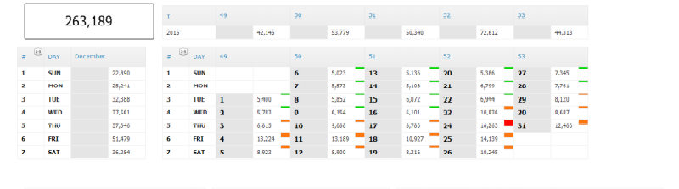

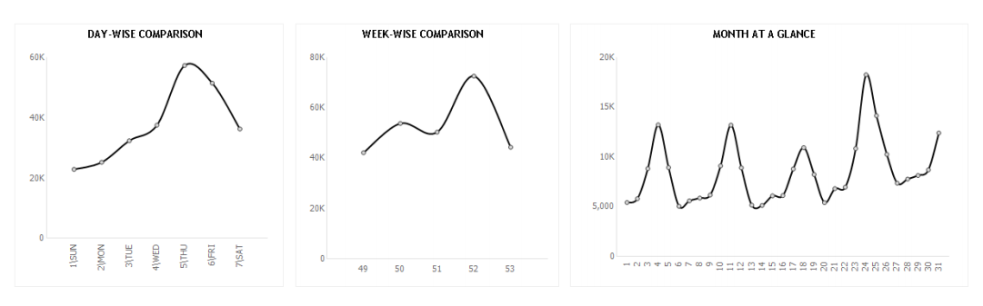

******************End of Calendar Summary Report******************

a.2) **Daily Trend Analysis Report**(we have done this report, we had named this report as HourlyTrafficReport2.html, just need to add 4 more columns to this)

**Table required fields: -**

* Time Period
* Visitors_In
* Past Day
* Past Day %
* Past Week
* Past Week %
* Past Month
* Past Month %
* Past Year
* Past Year %)

We have to add 4 more rows and columns to this report, which is “past month, past month %, past year, past year %”)

**Calculations for each row**

1. **Time Period:-**

We have to take**Date_Time**value from json feed **(pls note: - for Date_Time in json feed, we have as follows** "Date_Time": "2013-12-31 21:00:00.000", we need to take only the time, which is, 21:00:00 from this Date_Time and display here

1. **Visitors:-**

We have to take Visitors_In value from json feed

1. **Visitors(Prev Day)**

This value is calculated based on the date selection. For e.g.: - If I select 1/14/2016, Visitors previous day should be the value from 1/1/2016. If there is no value, then it should display “0” instead of”–“

1. **% change(Previous day)**

This value is calculated on this formula

**Current day visitors – Previous day visitors**

**_________________________________________ * 100**

**Previous day visitors**

1. **Visitors (Past week)**

This value is calculated based on the date selection. For e.g.:- If I select 1/14/2016 in the calendar, then it should take a week back from the current date selected in calendar... So if I have 1/14/2016(selected in calendar, which is a Thursday) then values shown here, should be last week Thursday (only last week Thursday) which is 1/7/2016, for that particular hour.

1. **% change (past week)**

This value is calculated on this formula

**Current week visitors – Previous week visitors**

**_________________________________________ * 100**

**Previous week visitors**

1. **Visitors (Past month)**

This value is calculated based on the date selection. For e.g.:- If I select 1/14/2016 in the calendar, then it should take a month back from the current date selected in calendar... So if I have 1/14/2016(selected in calendar) then values shown here should be a month back date which is 12/14/2015 and show that day’s value here.

(Same date past month, not entire month)

1. **% change (past month)**

This value is calculated on this formula

**Current Month Visitors – Previous Month Visitors**

**___________________________________________* 100**

**Previous Month visitors**

1. **Visitors Past year**

This value is calculated based on the date selection. For e.g.:- If I select 1/14/2016 in the calendar, then it should take a year back from the current date selected in calendar... So if I have 1/14/2016(selected in calendar) then values shown here should be the date 1/14/2015and its value should be shown here

(Same date past year, not entire year)

1. **% change(past year)**

This value is calculated on this formula

**Current Year Visitors – Previous Year Visitors**

**___________________________________________* 100**

**Previous Year visitors**

**Calculations for Div’s in this table:-**

1. **Total Visitors for day :-**take the**visitors_In**value from json feed and show the total for that particular day
2. **Total Visitors Previous Day:-**Based on the calendar selection we have made, it should take the previous day, and display the total visitors for the previous day
3. **Total Visitors for Previous Week:-**Based on the calendar selection we have made, it should take 7 days previous and display the total number of visitors for that day, eg:- selected day is Wednesday, then last week Wednesday value here

**Chart values: -** line chart (visitors in (black color), Past day (green color), Past week (Red color), Past month (Orange), Past year (brown) (keep what is there in the pdf)

(This is how the old report pic looked, have attached the new one)

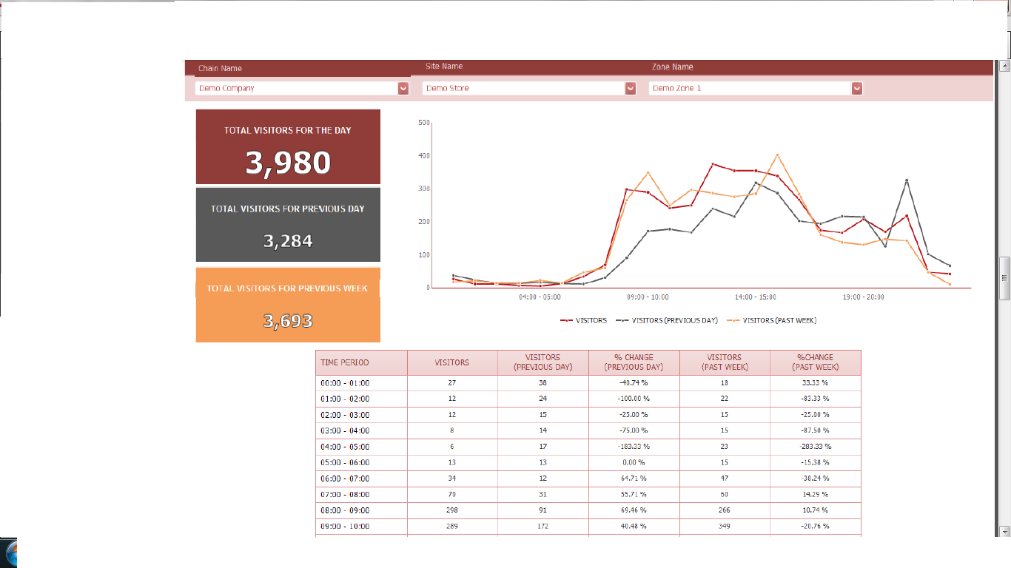

**Pls note: - here we have 5 divs instead of 3 in the previous one, also 4 new fields in the table as mentioned above**

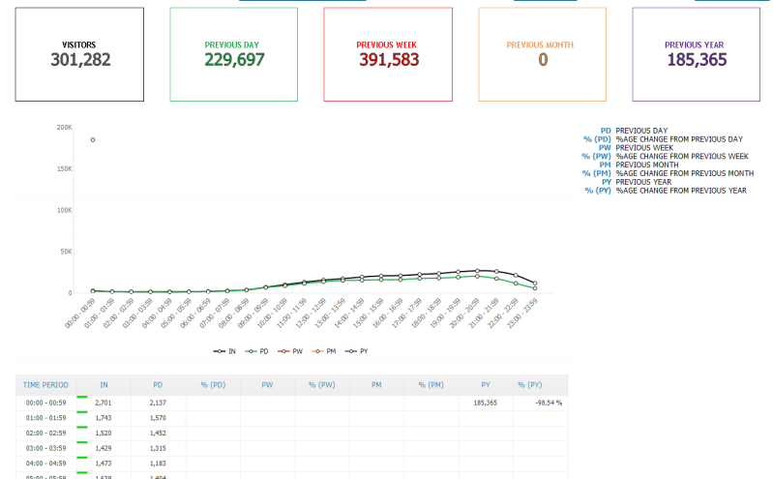

******************End of Trend Analysis Report******************

**a.3) Daily Comparison Report:-**

**a.3.1) DailySite Comparison Report: -**(I guess we have done this report)

**Table required fields**: -

* “time period”
* also when clicked on particular sites from drop-down, they should display all those values in table

**Calculations for each row**

1. **Time Period:-**

We have to take**Date_Time**value from json feed **(pls note: - for Date_Time in json feed, we have as follows** "Date_Time": "2013-12-31 21:00:00.000", we need to take only the time, which is, 21:00:00 from this Date_Time and display here

**Pls note: - Charts not shown here, but let’s keep the bar chart that we have**

(This is how it looks)

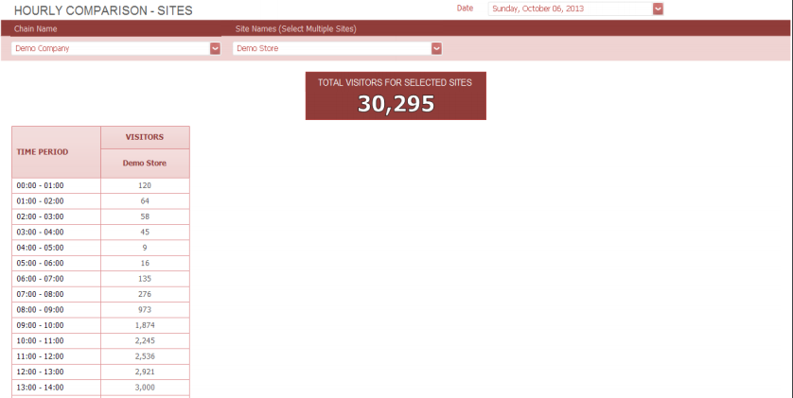

**This is how when I select 3 sites will look like**

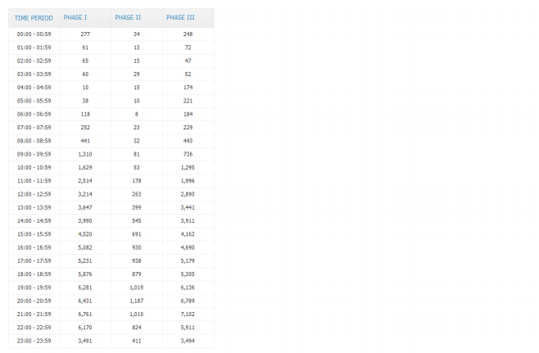

******************End of Site Comparison Report******************

**a.3.2) DailyZone Comparison Report: - (same report just replacing sites to zones)**

**Table required fields**: -

* “time period”
* also when clicked on particular zones from drop-down, they should display all those values in table

**Calculations for each row**

1. **Time Period:-**

We have to take**Date_Time**value from json feed **(pls note: - for Date_Time in json feed, we have as follows** "Date_Time": "2013-12-31 21:00:00.000", we need to take only the time, which is, 21:00:00 from this Date_Time and display here

Pls note: - instead of sites, here, it would be zone

**Pls note: - Charts not shown here, but let’s keep the bar chart for this report also**



******************End of Zone Comparison Report*****************

**a.4) Daily Hourly Report: -**(we have done this report, calculation has to be changed)

**Table required fields**: -

* time period
* visitors

**Calculations for each row**

1. **Time Period:-**

We have to take**Date_Time**value from json feed **(pls note: - for Date_Time in json feed, we have as follows** "Date_Time": "2013-12-31 21:00:00.000", we need to take only the time, which is, 21:00:00 from this Date_Time and display here

1. **Visitors:-**

We have to take Visitors_In value from json feed

**Chart values: -bar chart**

(This is how the report looked)

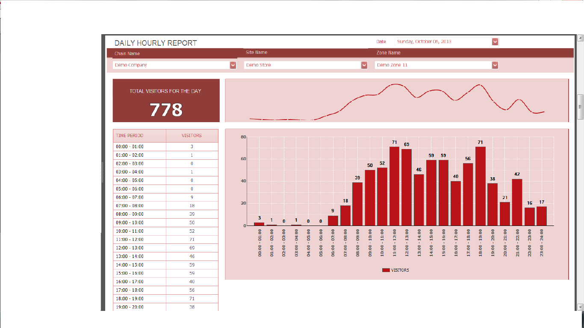

******************End of Hourly Report************************************

B) **Daily Retail Performance Report: -(we have done this report, calculation needs to be checked)**

**B.1)Daily Retail Trend Analysis Report:-**

**Table required fields**: -

* Visitors Current Day
* Visitors Past Day
* Visitors Past Week
* Visitors Past Month
* Visitors Past Year
* Conversion Current Day
* Conversion Past Day
* Conversion Past Week
* Conversion Past Month
* Conversion Past Year
* Transaction Current Day
* Transaction Past Day
* Transaction Past Week
* Transaction Past Month
* Transaction Past Year
* Sales Current Day
* Sales Past Day
* Sales Past Week
* Sales Past Month
* Sales Past Year
* Items Sold Current Day
* Items Sold Past Day
* Items Sold Past Week
* Items Sold Past Month
* Items Sold Past Year

**Calculations for each row**

1. **Visitors Current day:-**

* **Take this value from feed (Visitors_In)**
* **No variance for first row**

1. **Visitors Past Day:-**

* **To get 1st value in the block, Current day -1 from the selected date**
* **Variance calculation: - Current Day visitors - Past day visitors / current day visitors * 100 (we get a value shown on the pic) – 20.63 %**

1. **Visitors Past Week:-**

* **To get 1st value in the block, Current day (eg:- if today is Wednesday, then last week Wednesday’s value here)**
* **Variance calculation: - Current Day visitors - Past week visitors / current day visitors * 100 (we get a value shown on the pic) 9.11%**

1. **Visitors Past Month:-**

* **To get 1st value in the block, (eg:- if today is 1/14/2016, then last month 12/14/2015 value should be shown here)**
* **Variance calculation: - Current Day visitors - Past month visitors / current day visitors * 100 (we get a value shown on the pic) – 21.14 %**

1. **Visitors Past Year:-**

* **To get 1st value in the block, Current day -365 days(check for leap year also) from the selected date (look out for the leap year)**
* **Variance calculation: - Current Day visitors - Past year visitors / current day visitors * 100 (we get a value shown on the pic) – 17.47 %**

1. **Conversion Current Day:-**

* **Current day Transaction / Current Day visitors * 100(we get the value shown in the table pic below 31.27%)**

1. **Conversion Past Day:-**

* **To get 1st value in the block, Transaction Past Day / Past Day Visitors * 100**
* **Variance calculation: - Current Day conversion - Past day conversion / current day conversion(we get the value shown in the table pic below 24.82 %)**

1. **Conversion Past week:-**

* **To get 1st value in the block, Transaction Past Week / Past Week Visitors* 100**
* **Variance calculation: - Current Day conversion - Past week conversion / current day conversion (we get the value shown in the table pic below 21.60 %)**

1. **Conversion Past Month:-**

* **To get 1st value in the block, Transaction Past Month / Past Month Visitors * 100**
* **Variance calculation: - Current Day conversion - Past month conversion / current day conversion (we get the value shown in the table pic below 13.77 %)**

1. **Conversion Past Year:-**

* **To get 1st value in the block, Transaction Past Year / Past Year Visitors * 100**
* **Variance calculation: - Current Day conversion - Past year conversion / current day conversion (we get the value shown in the table pic below 0.91 %)**

1. **Transaction Current Day:-**

* **To get 1st value in the block, from feed take “Transactions” value**
* **No variance for first row**

1. **Transaction Past Day:-**

* **To get 1st value in the block, Current day -1 day from the selected date**
* **Variance calculation: - Current Day Transaction – Transaction Past Day / Current Day Transaction * 100**

1. **Transaction Past Week:-**

* **To get 1st value in the block, Current day (e.g.:- if today is Wednesday, then last week Wednesday’s value here)**
* **Variance calculation: - Current Day Transaction – Transaction Past Week / Current Day Transaction * 100**

1. **Transaction Past Month:-**

* **To get 1st value in the block, Current day (e.g.:- if today is 1/14/2016, then last month 12/14/2015 value here)**
* **Variance calculation: - Current Day Transaction – Transaction Past Month / Current Day Transaction * 100**

1. **Transaction Past Year:-**

* **To get 1st value in the block, Current day (e.g.:- if today is 1/14/2016, then last year 1/14/2015 value here)**
* **Variance calculation: - Current Day Transaction – Transaction Past Year / Current Day Transaction * 100**

1. **Sales Current Day:-**

* **To get 1st value in the block, from feed take “Sales” value**
* **No variance for first row**

1. **Sales Past Day:-**

* **To get 1st value in the block, Current day -1 day from the selected date**
* **Variance calculation: - Current Day Sales – Sales Past Day / Current Day Sales * 100**

1. **Sales Past week:-**

* **To get 1st value in the block, Current day (e.g.:- if today is Wednesday, then last week Wednesday’s value here)**
* **Variance calculation: - Current Day Sales – Sales Past Week / Current Day Sales * 100**

1. **Sales Past Month:-**

* **To get 1st value in the block, Current day (e.g.:- if today is 1/14/2016, then last month 12/14/2015 value here)**
* **Variance calculation: - Current Day Sales – Sales Past Month / Current Day Sales * 100**

1. **Sales Past Year:-**

* **To get 1st value in the block, Current day (e.g.:- if today is 1/14/2016, then last year 1/14/2015 value here)**
* **Variance calculation: - Current Day Sales – Sales Past Year / Current Day Sales * 100**

1. **Items Sold Current day:-**

* **To get 1st value in the block, from feed take “Items” value**
* **No variance for first row**

1. **Items Sold Past Day:-**

* **To get 1st value in the block, Current day -1 day from the selected date**
* **Variance calculation: - Current Day Items – Items Past Day / Current Day Items * 100**

1. **Items Sold Past Week:-**

* **To get 1st value in the block, Current day (e.g.:- if today is Wednesday, then last week Wednesday’s value here)**
* **Variance calculation: - Current Day Items – Items Past Week / Current Day Items * 100**

1. **Items sold Past Month:-**

* **To get 1st value in the block, Current day (e.g.:- if today is 1/14/2016, then last month 12/14/2015 value here)**
* **Variance calculation: - Current Day Items – Items Past Month / Current Day Items * 100**

1. **Items Sold Past Year:-**

* **To get 1st value in the block, Current day (e.g.:- if today is 1/14/2016, then last year 1/14/2015 value here)**
* **Variance calculation: - Current Day Items – Items Past Year / Current Day Items * 100**

(This is how the report looked)

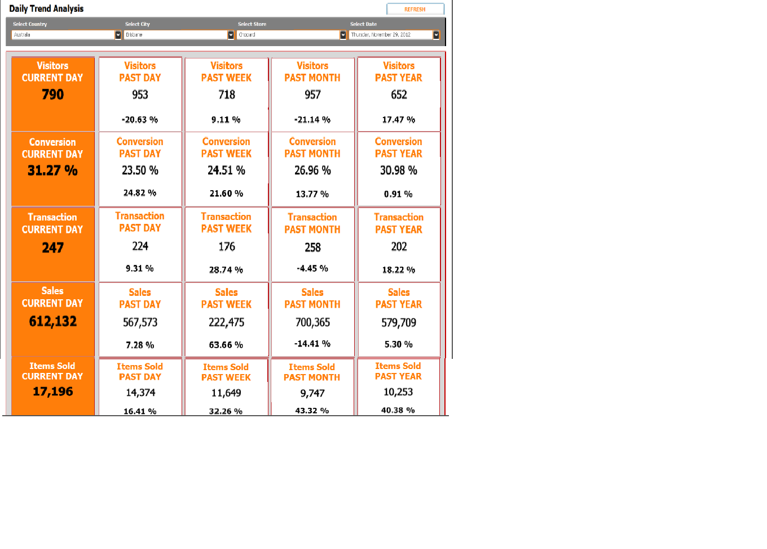

**\*\*\*\*\*\*\*\*\*\*\*\*\*\*\*\*\*\*\*End ofTrend Analysis Report\*\*\*\*\*\*\*\*\*\*\*\*\*\*\*\*\*\***

**B.2) Daily Executive Summary Report: - (we have done this report, calculation needs) pls note:-here single date will be selected**

**Table required fields**: -

* **Visitors**
* **Sales**
* **Transaction**
* **Items Sold**
* **Staff**
* **Conversion**
* **Avg. Sales**
* **Avg. Customer Value**
* **Avg. Basket Size**
* **Customer to Staff Ratio**
* **Items Per Customer**
* **Sales Per Staff**

**Calculations for each row**

1. **Visitors:-**

From feed take value “Visitors_In”

1. **Sales:-**

From feed take value “Sales”

1. **Transaction:-**

From feed take value “Transactions”

1. **Items Sold:-**

From feed take value “Items”

1. **Staff:-**

From feed take value “Associates”

1. **Conversion:-**

Transaction / Visitors_In * 100

1. **Avg. Sales:-**

Sales / Transaction

1. **Avg. Customer Value:-**

Sales / Visitors_In

1. **Avg. Basket Size:-**

Items / Transaction

1. **Customer to Staff Ratio:-**

Visitors / Staff (Associates)

1. **Items Per Customer:-**

Items / Visitors_In

1. **Sales Per Staff:-**

Sales / Staff (Associates)

(This is how the report looked)

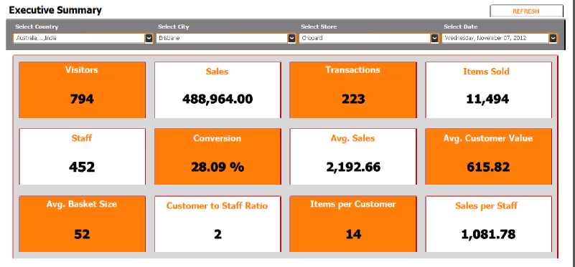

**\*\*\*\*\*\*\*\*\*\*\*\*\*\*\*\*End of Executive Summary Report\*\*\*\*\*\*\*\*\*\*\*\*\***

**B.3) Daily Retail Performance Report: -(we have done this report, also known as Daily Traffic Trend analysis Report, calculation needs to be checked)**

**Table required fields**: -

* time period
* visitors
* Sales
* Trans
* Staff
* %Conv
* Avg Sales
* AvgCust Value
* Avg Basket Size
* Star
* Items Per Cust
* Sales Per Staff

**Calculations for each row**

1. **Time Period:-**

We have to take**Date_Time**value from json feed **(pls note: - for Date_Time in json feed, we have as follows** "Date_Time": "2013-12-31 21:00:00.000", we need to take only the time, which is, 21:00:00 from this Date_Time and display here

1. **Visitors:-**

We have to take **Visitors_In** value from json feed

1. **Sales:-**

WE have to take “**Sales”** value from json feed

1. **TRANS :-**

We have to take **“Trans**” value from json feed

1. **ITEMS:-**

We have to take “**Items”** value from json feed

1. **STAFF:-**

WE have to take “**Associate”** value from json feed

1. **%CONV:-**

(Transaction / visitors)

1. **AVG SALES:-**

(Sales / Transaction)

1. **AVG CUST VALUE:-**

(Items / Transaction)

1. **AVG BASKET SIZE:-**

(Staff (Associates) / Visitors_In)

1. **STAR:-**

(Staff (Associates) / visitors_in)

1. **ITEMS PER CUST:-**

(Items /Visitors_in)

1. **Sales Per Staff:-**

(Sales / Staff (Associates))

**Chart Values:-**

* Bar chart
* Visitors value in bar
* %conv line chart

(This is how the report looked)

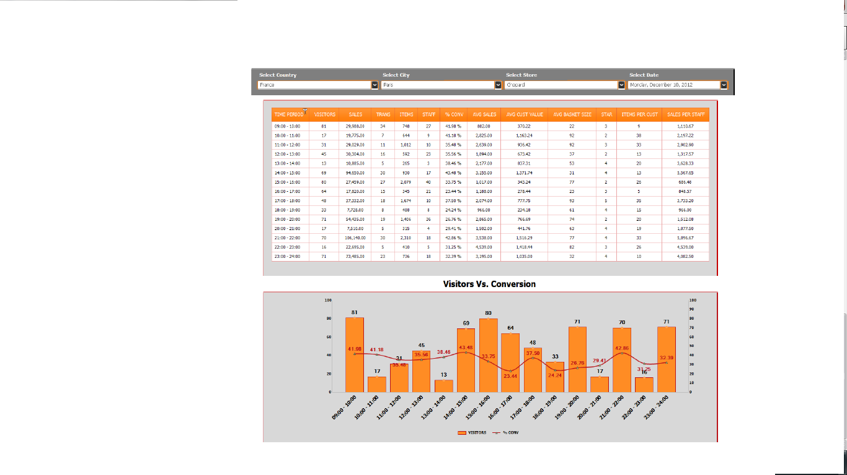

*****************End of Daily Retail Performance Report****************

2) Weekly Reports

**a) Weekly Traffic Reports**

**a.1) Weekly Traffic Report(not sure if we have done this report)**

**Table required fields**: -

🡪 Days

* Visitors

**Calculations for each row**

🡪**Days**

The selected week from the calendar has to display the dates in the day column

* **Visitors**

We have to take “**Visitors_In”** from feed

**Colors Calculation:-** Additional feature in the present software, this was the calculation there for the colors, not very sure, but this is the best calculation I could get

**Green:-**[IN] <= (Min([IN])+Max([IN]))/3  
  
**Orange:-** [IN] > (Min([IN])+Max([IN]))/3 AND [IN] <= ((Min([IN])+Max([IN]))/3)*2  
  
**Red:-** [IN] > ((Min([IN])+Max([IN]))/3)*2

**Chart Values:-**

* **Bar chart**
* **Bar chart for visitors values (use the design of the new picture attached)**

(This is how the report looked)

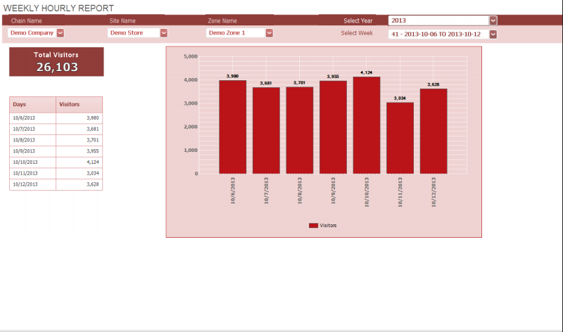

**WE have to change the same report to the below new report with new fields**

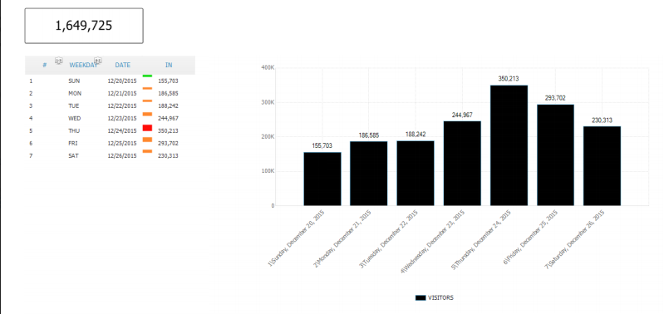

*************End of Weekly Traffic Report***************************

**a.2) Five Week Comparison Report(not sure if we have done this report)**

**Table required fields**: -

* Mall Entrances
* Weeks (17, 18, 19, 20, 21)

**Calculations for each row**

* **Mall Entrances**

Take the value “Zone_Name” from the feed, now, this will show the zones that has been selected

* Weeks

The week that has been selected, will be displayed along with the visitors for complete 7 days

Pls note: values will be shown based on the selection of “Site”, i.e. if I select a site called Juicy Couture-MOE and if it has 10 zones associated with it, then all those 10 zones should be displayed for the selected week

(This is how the report looked)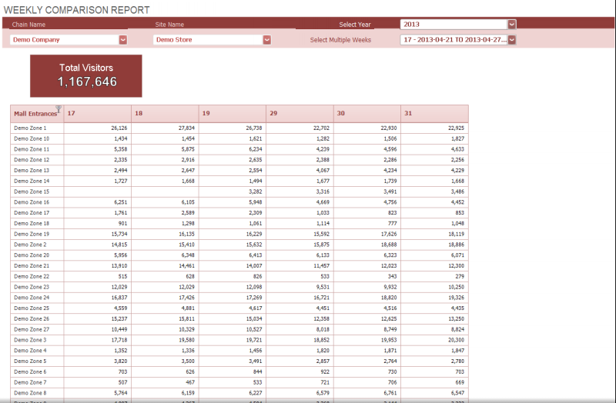

*************End of Five Week Comparison Report***************************

**a.3) Key Hour Report(we have done this report, calculation needs to be checked)**

**Table required fields**: -

* Days
* Hourly

**Calculations for each row**

* **Days:- Selected Week days will be displayed**
* **Hours: -Not very sure of the calculation here, was a feature of old software... Here, for e.g.: - then this 40 if I have 40 visitors in a day, visitors is divided over 100 percent for each hour… let’s say we have hours shown from 9:00 am – 10 pm... We would have 14 rows... so calculation is done based on the rows, visitors for each hour and 100 percent, if we choose 24 hours to be displayed, calculation would change accordingly.**
* **we need a time filter… this means, we can choose which hours we want to display, or display 24 hours together**

Pls note: - When I select a chain, and site and zone and a particular week, then the value would be shown in the report

(This is how the report looked)

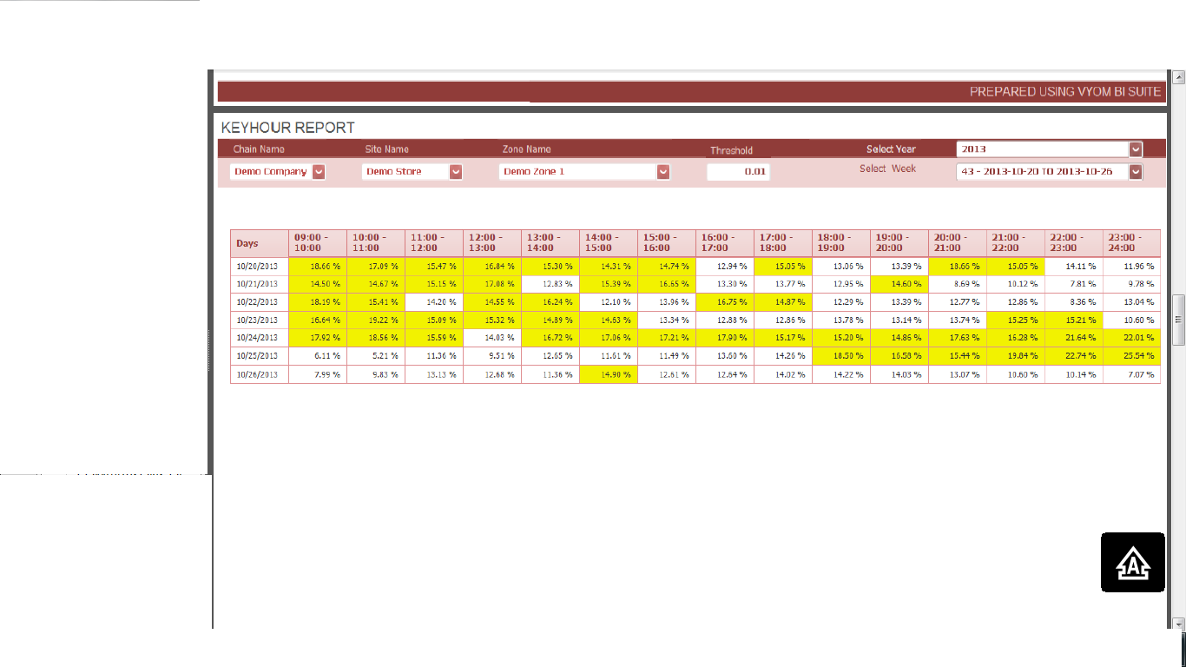

**New report looks like this, only difference is that a total is here on top**

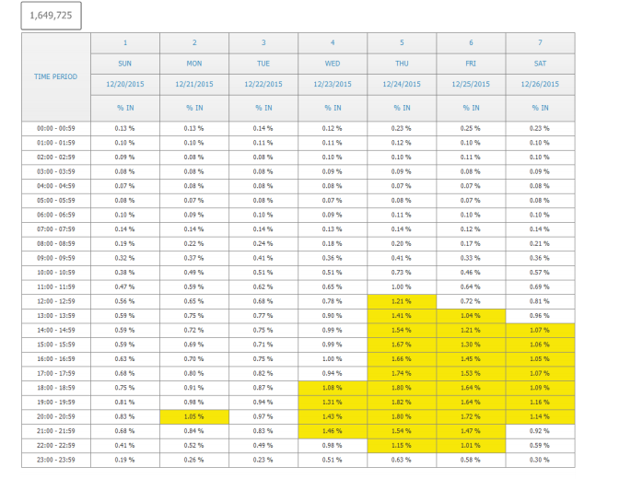

*************End of Key Hour Report***************************

**a.4) Weekly Comparison Entrances**

**Table required fields**: -

None

**Div.: - will show the Total Visitors for the week**

**Calculations for each row**

**This report will show the visitors for the each zone selected, with their values in the chart**

(This is how the report looked)

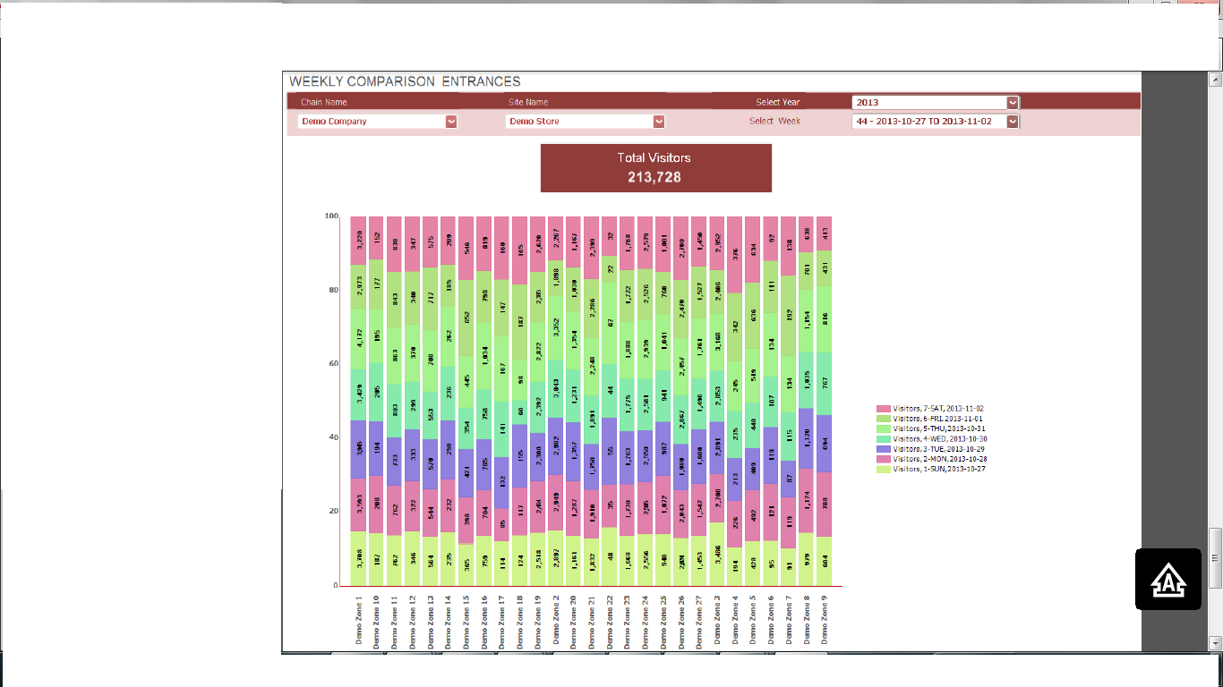

*************End of Weekly Comparison Entrances Report*******************

2. B) **Weekly Retail Performance Report**

**B.1) Weekly Executive Summary Report (same as the executive Summary Report in Daily Retail Performance Report) pls note: - here, instead of date, week will be selected**

**Table required fields**: -

* **Visitors**
* **Sales**
* **Transaction**
* **Items Sold**
* **Staff**
* **Conversion**
* **Avg. Sales**
* **Avg. Customer Value**
* **Avg. Basket Size**
* **Customer to Staff Ratio**
* **Items Per Customer**
* **Sales Per Staff**

**Calculations for each row**

1. **Visitors:-**

From feed take value “Visitors_In”

1. **Sales:-**

From feed take value “Sales”

1. **Transaction:-**

From feed take value “Transactions”

1. **Items Sold:-**

From feed take value “Items”

1. **Staff:-**

From feed take value “Associates”

1. **Conversion:-**

Transaction / Visitors_In * 100

1. **Avg. Sales:-**

Sales / Transaction

1. **Avg. Customer Value:-**

Sales / Visitors_In

1. **Avg. Basket Size:-**

Items / Transaction

1. **Customer to Staff Ratio:-**

Visitors / Staff (Associates)

1. **Items Per Customer:-**

Items / Visitors_In

1. **Sales Per Staff:-**

Sales / Staff (Associates)

**(This is how the report looks)**



**\*\*\*\*\*\*\*\*\*\*\*\*\*\*\*\*\*\*\*End of Weekly Retail Performance Report\*\*\*\*\*\*\*\*\*\*\*\*\*\*\*\***

**B.2) Comparison Report**

**B.2.1) Site Comparison Report (yet to be given)**

**B.2.2) Zone Comparison Report (yet to be given)**

**B.3) Weekly Trend Analysis Report**

**Table required fields**: -

Calculation same as we see in the Daily Retail Trend Analysis Report (pls refer that report) here, instead of date, we will select week wise

**Calculations for each row**

1. **Visitors Current week:-**

* **To get 1st value in the block, we need to calculate it as week number, in a year we have 52 weeks and 53 weeks for a leap year, ISO standard for week shows that Monday is the first day and Sunday is the last day… so current week visitors means, if I have selected January 4th 2016 date, it comes under the 1st week number of the year**
* **No variance for first row**

1. **Visitors Past Week:-**

* **To get value in the block, Current week – past week from the selected date, for e.g.:- if I have selected January 13th 2016 Wednesday, it’s the 2nd week of the year, so here, past week visitors meaning… showing the 1st week visitors of the year**
* **Variance calculation: - Current Week visitors - Past week visitors / current Week visitors * 100**

1. **Visitors Past Year:-**

* **To get value in the block, Current week of the year checking for the same week in the last year (check for leap year also)**
* **Variance calculation: - Current Week visitors - Past year same week visitors / current week visitors * 100**

1. **Conversion Current Week:-**

* **Current week Transaction / Current week visitors * 100**

1. **Conversion Past week:-**

* **To get value in the block, Transaction Past Week / Past Week Visitors * 100**
* **Variance calculation: - Current week conversion - Past week conversion / current week conversion**

1. **Conversion Past Year:-**

* **To get value in the block, Transaction Past Year / Past Year same week Visitors * 100**
* **Variance calculation: - Current week conversion - Past year same week conversion / current week conversion**

1. **Transaction Current Week:-**

* **To get 1stvalue in the block, check for transaction of the entire week selected, week wise, not day wise...pls note**
* **No variance for first row**

1. **Transaction Past Week:-**

* **To get value in the block, check for transaction of the entire week selected against the past week, week wise, not day wise... pls note**
* **Variance calculation: - Current Week Transaction – Transaction Past Week / Current Week Transaction * 100**

1. **Transaction Past Year:-**

* **To get value in the block, Current week of the year checking for the same week in the last year (check for leap year also)**
* **Variance calculation: - Current Week Transaction – Transaction Past Year of the same week / Current Week Transaction * 100**

1. **Sales Current Week:-**

* **To get value in the block, check for sales of the entire week selected, week wise, not day wise... pls note**
* **No variance for first row**

1. **Sales Past week:-**

* **To get value in the block, check for sales of the entire week selected against the past week, week wise, not day wise... pls note**
* **Variance calculation: - Current WeekSales – Sales Past Week / Current WeekSales * 100**

1. **Sales Past Year:-**

* **Current week of the year checking for the same week in the last year (check for leap year also)**
* **Variance calculation: - Current WeekSales – Sales Past Year of the same week / Current WeekSales * 100**

1. **Items Sold Current Week:-**

* **To get value in the block, check for Items of the entire week selected, week wise, not day wise... pls note**
* **No variance for first row**

1. **Items Sold Past Week:-**

* **To get value in the block, check for items of the entire week selected against the past week, week wise, not day wise... pls note**
* **Variance calculation: - Current WeekItems – Items Past Week / Current weekItems * 100**

1. **Items Sold Past Year:-**

* **Current week of the year checking for the same week in the last year (check for leap year also)**
* **Variance calculation: - Current WeekItems – Items Past Yearof the same week selected/ Current WeekItems * 100**

(This is how the report looked)

**Pls note, when we create a table, we won’t be showing Past Day and Past Month for this Report**



*************End of Weekly Trend Analysis Report*****************

1. **Monthly Reports**
2. **Monthly Traffic Reports**

a.1) **Monthly Performance Report**

**Table required fields**: -

* Days
* Visitors (shown as In in picture below)

**Calculations for each row**

1. Days:- This value is fetched from the feed, where it shows the different days
2. Visitors:- This values is fetched from the Visitors_In from the feed

* Div shows the total of all visitors in that month
* **Colors Calculation:-** Additional feature in the present software, this was the calculation there for the colors, not very sure, but this is the best calculation I could get

**Green:-**[IN] <= (Min([IN])+Max([IN]))/3  
  
**Orange:-** [IN] > (Min([IN])+Max([IN]))/3 AND [IN] <= ((Min([IN])+Max([IN]))/3)*2  
  
**Red:-** [IN] > ((Min([IN])+Max([IN]))/3)*2

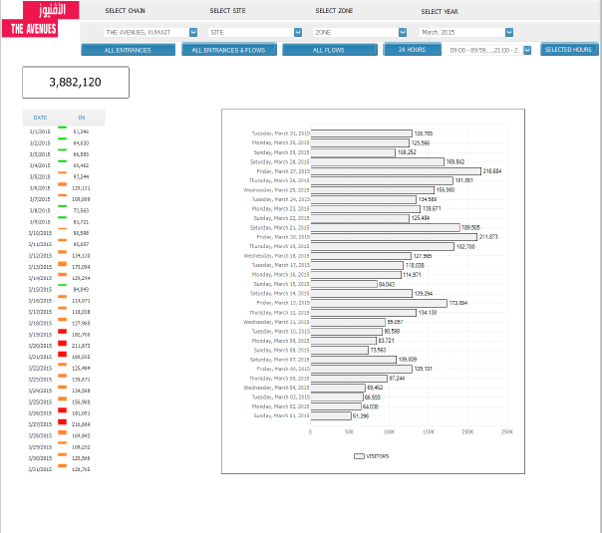

****************End of Monthly Performance Report***************

a.2) **Monthly Comparison Report**

**Table required fields**: -

* Calendar Day
* Visitors
* Show the selected months visitors per day

**Calculations for each row**

1. **Calendar Day:- Take the calendar day days and display them**
2. **Visitors:- show the value for each day from the feed Visitors_In**
3. **Finally, show the selected months and its value just like shown in the report**

(This is how the report looks)

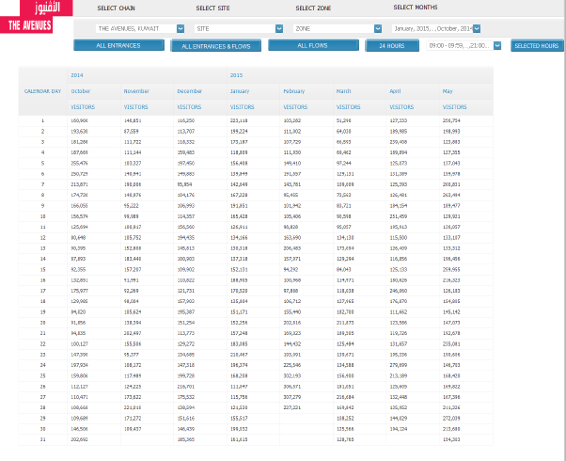

****************End of Monthly Comparison Report**********************

a.3) **Monthly Key Hour Report**

**Table required fields**: -

* Days
* Hourly
* We have threshold here

**Calculations for each row**

1. **Days value is taken from the selected month**
2. **Hours: - Not very sure of the calculation here, was a feature of old software... Here, for e.g.: - if I have 40 visitors in a day, then this 40 visitors is divided over 100 percent for each hour… let’s say we have hours shown from 9:00 am – 10 pm... We would have 14 rows... so calculation is done based on the rows, visitors for each hour and 100 percent, if we choose 24 hours to be displayed, calculation would change accordingly.**
3. **we need a time filter… this means, we can choose which hours we want to display, or display 24 hours together**
4. **Should also show a total number of visitors on top**

(This is how the report looked like)

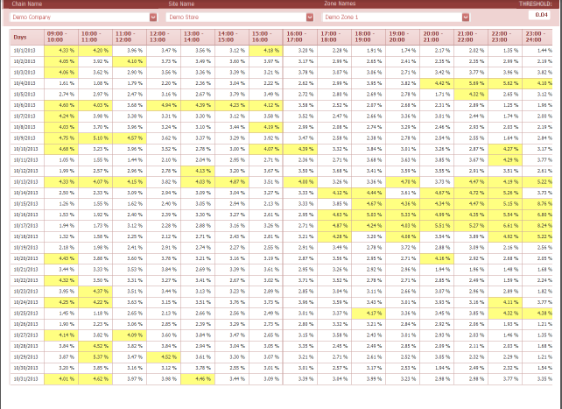

************End of Monthly Key Hour Report************************

1. **Monthly Retail Performance Report**

b.1) **Monthly Executive Summary Report**(Same as Daily Executive Summary Report, only difference is that, here, instead of days, we would be selecting months to show the values)

**Table required fields**: -

* **Visitors**
* **Sales**
* **Transaction**
* **Items Sold**
* **Staff**
* **Conversion**
* **Avg. Sales**
* **Avg. Customer Value**
* **Avg. Basket Size**
* **Customer to Staff Ratio**
* **Items Per Customer**
* **Sales Per Staff**

**Calculations for each row**

1. **Visitors:-**

From feed take value “Visitors_In”

1. **Sales:-**

From feed take value “Sales”

1. **Transaction:-**

From feed take value “Transactions”

1. **Items Sold:-**

From feed take value “Items”

1. **Staff:-**

From feed take value “Associates”

1. **Conversion:-**

Transaction / Visitors_In * 100

1. **Avg. Sales:-**

Sales / Transaction

1. **Avg. Customer Value:-**

Sales / Visitors_In

1. **Avg. Basket Size:-**

Items / Transaction

1. **Customer to Staff Ratio:-**

Visitors / Staff (Associates)

1. **Items Per Customer:-**

Items / Visitors_In

1. **Sales Per Staff:-**

Sales / Staff (Associates)

(This is how the report looked)



*************End of Monthly Executive Summary Report**********************

b.2) **Monthly Analysis Report**(Same as Daily Retail Performance Report) only difference here, instead of time period, we would be showing the months)

**Table required fields**: -

* time period
* visitors
* Sales
* Trans
* Staff
* %Conv
* Avg Sales
* AvgCust Value
* Avg Basket Size
* Star
* Items Per Cust
* Sales Per Staff

**Calculations for each row**

1. **Time Period:-**

We have to take**Date_Time**value from json feed **(pls note: - for Date_Time in json feed, we have as follows** "Date_Time": "2013-12-31 21:00:00.000", we need to take only the time, which is, 21:00:00 from this Date_Time and display here

1. **Visitors:-**

We have to take **Visitors_In** value from json feed

1. **Sales:-**

WE have to take “**Sales”** value from json feed

1. **TRANS :-**

We have to take **“Trans**” value from json feed

1. **ITEMS:-**

We have to take “**Items”** value from json feed

1. **STAFF:-**

WE have to take “**Associate”** value from json feed

1. **%CONV:-**

(Transaction / visitors)

1. **AVG SALES:-**

(Sales / Transaction)

1. **AVG CUST VALUE:-**

(Items / Transaction)

1. **AVG BASKET SIZE:-**

(Staff (Associates)/ Visitors_In)

1. **STAR:-**

(Staff (Associates) / visitors_in)

1. **ITEMS PER CUST:-**

(Items /Visitors_in)

1. **Sales Per Staff:-**

(Sales / Staff (Associates))

(This is how the report looked)



*****************End of Monthly Analysis Report***************************

b.3) **Monthly Retail Performance Report**

**Table required fields**: -

Calculation same as we see in the Daily Retail Performance Report (pls refer that report) here, instead of time period, we will show the days of the entire month

**Calculations for each row**

1. **days:-**

We have to show **the days from the selected month**

1. **Visitors:-**

We have to take **Visitors_In** value from json feed

1. **Sales:-**

WE have to take “**Sales”** value from json feed

1. **TRANS :-**

We have to take **“Trans**” value from json feed

1. **ITEMS:-**

We have to take “**Items”** value from json feed

1. **STAFF:-**

WE have to take “**Associate”** value from json feed

1. **%CONV:-**

(Transaction / visitors)

1. **AVG SALES:-**

(Sales / Transaction)

1. **AVG CUST VALUE:-**

(Items / Transaction)

1. **AVG BASKET SIZE:-**

(Staff (Associates) / Visitors_In)

1. **STAR:-**

(Staff (Associates) / visitors_in)

1. **ITEMS PER CUST:-**

(Items /Visitors_in)

1. **Sales Per Staff:-**

(Sales / Associate)

In this report, we have Time_period, instead of that, we want to show day wise, like the entire days of the month with the same other fileds



*******************End of Monthly Retail Performance Report******************

1. **Yearly Reports**
2. **Yearly Traffic Reports**

a.1) **YTD Report(yet to be done)**

**Table required fields**: -

* Time period
* Sales
* %Conversion
* Transaction
* Visitors_in(Traffic)
* Average Transaction Size
* Sales / shopper
* Labor (Associate)
* Star (Staff Ration)

**Calculations for each row**

**In this report… Date selection is important**

**For e.g.:- If I select June 3rd 2016, current date is Jan 19th 2016, so according to this report, it will show the months from Jan to June in time period, but values would be displayed only for the month of January coz we r currently in the month of January, rest of the months from Feb to June, it will display value “0”**

**Same time, if I go back and select last year’s date, then month should be displayed accordingly with the value**

1. Time Period:- Display the selected months with the year
2. Sales:- take this value from the feed “Sales”
3. %Conversion:- transaction / Visitors_In *100
4. Transaction:- Take this value from the feed “Transaction”
5. Traffic(Visitors_In):- Take this value from the feed “Visitors_In)
6. Average Transaction Size:- sales / transaction
7. Sales / Shopper:- sales / Visitors_In
8. Labor:- take this value from the feed “Associate”
9. Star:- Visitors_In / Labor (Associate)

(This is how the report looks)

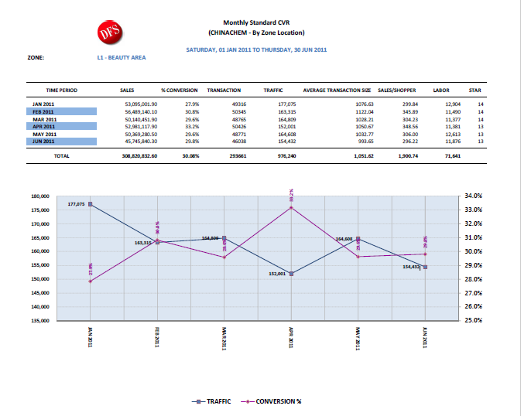

*****************End of YTD Report***********************